A Pretargeted Strategy for Imaging EGFR Positive Colorectal Carcinoma via the Modulation of Radioligand-Tz Pharmacokinetics
Lin Qiu^{1,2,3,4}, Hui Tan^{1,3,4}, Qingyu Lin^{1,3,4}, Zhan Si^{1,3,4}, Jun Zhou^{1,3,4}, Tingting Wang^{1,3,4}, Dengfeng Cheng^{1,3,4}*, and Hongcheng Shi^{1,3,4}*
¹Department of Nuclear Medicine, Zhongshan Hospital, Fudan University, Shanghai, China; ²Department of Nuclear Medicine, Affiliated Hospital of Southwest Medical University, Luzhou, Sichuan, China; ³Institute of Nuclear Medicine, Fudan University, Shanghai, China; ⁴Shanghai Institute of Medical Imaging, Shanghai, China.
*.Corresponding authors: Dengfeng Cheng (Telephone:86-13681927549; Email: cheng.dengfeng@zs-hospital.sh.cn) and Hongcheng Shi (Telephone:86-13681971579; Email: shihongcheng163@163.com). Institution: Department of Nuclear Medicine, Zhongshan Hospital, Fudan University, Shanghai 200032, China; Address: No. 180, fenglin road, xuhui district, Shanghai.

CONTENTS:
HPLC
Synthesis of HYNIC-Polypeptide-PEG₁₁-Tz
Xenograft Models
Supplementary Results

HPLC
High performance liquid chromatography (HPLC) analysis of HYNIC-PEG₁₁-Tz and HYNIC-Polypeptide-PEG₁₁-Tz was performed using an Agilent HPLC equipped with a Gemini 5 µm NX-C₁₈ reversed-phase column (Phenomenex Luna analytical 4.6×150 mm), 2 LC-10AT pumps, a SPD-M10AVP photodiode array detector, a Bioscan Flow Counts radioactivity detector, and the following systems: (A) water/0.1% TFA and (B) ACN/0.1% TFA as mobile phases (15 to 45% B in 20 min). HPLC analysis of large molecular antibody was performed using a size exclusion chromatography HPLC (SEC-HPLC, Agilent Technologies, 1260 Infinity. PBS, 0.7 ml/min).

Synthesis of HYNIC-Polypeptide-PEG₁₁-Tz
Synthetic Summary:
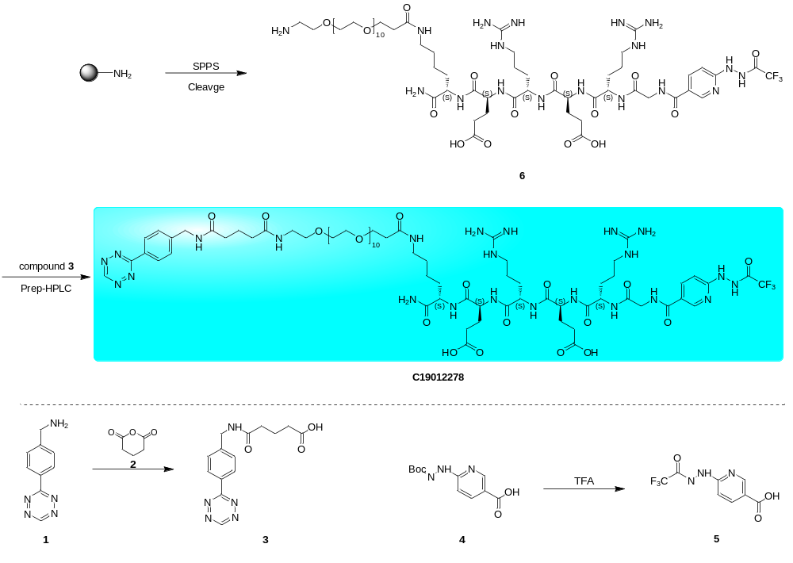
General procedure for preparation of compound 3: 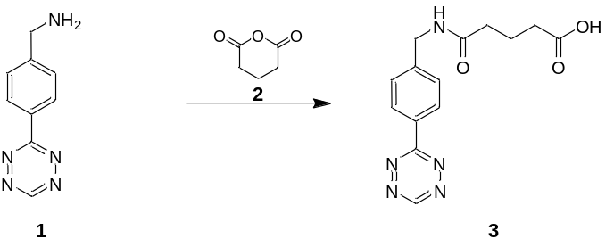
To a solution of compound 1 (200 mg, 894 μmol, HCl) and compound 2 (153 mg, 1.34 mmol) in DCM (2.00 ml) was added TEA (271 mg, 2.68 mmol). The mixture was stirred at 20 °C for 1 h. The reaction was monitored by TLC, it was showed the starting material consumed. The mixture was removed in vacuum. The crude product was purified by column chromatography on silica gel (100-200 mesh size) using DCM/MeOH (50:1) as eluent to give compound 3 (200 mg, 73.9% yield) as a red solid.
LCMS: ES11814-1-P1A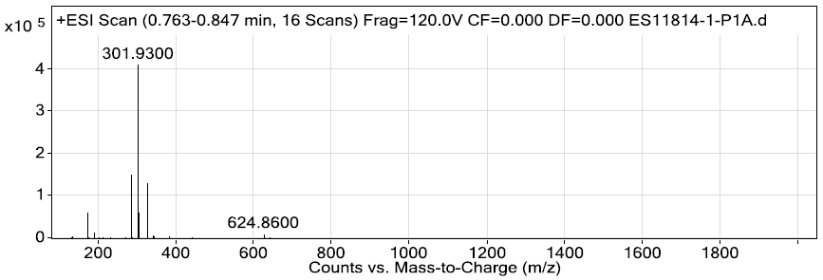
HPLC: ES11814-1-P1C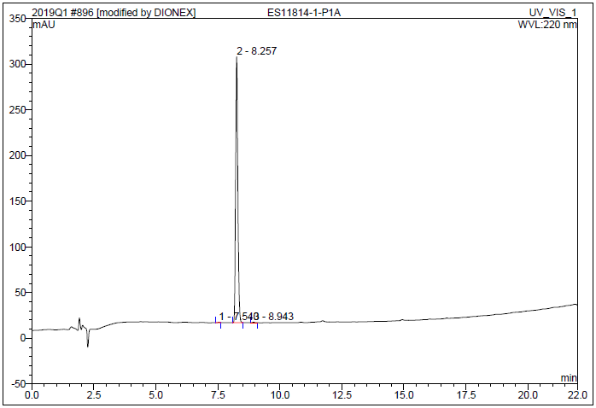
General procedure for preparation of compound 5:
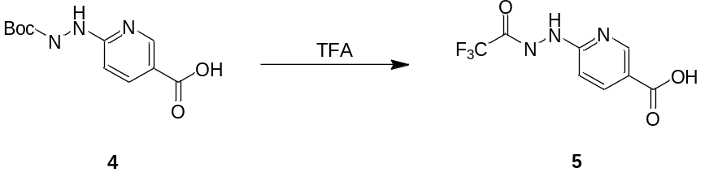
To a solution of compound 4 (800 mg, 3.16 mmol) was added TFA (12.3 g, 108 mmol) The mixture was stirred at 20 °C for 12 h. LCMS showed starting material was consumed, LCMS showed the desired mass. TFA was removed in vacuum, then the resulting product was freeze-dried to afford compound 5 (600 mg, 76.2% yield) as a yellow solid.
LCMS: ES11814-4-P1A
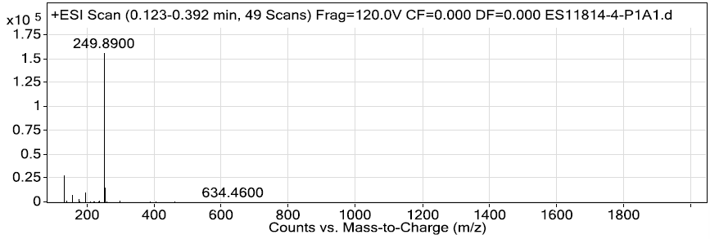
General procedure for preparation of compound 6:
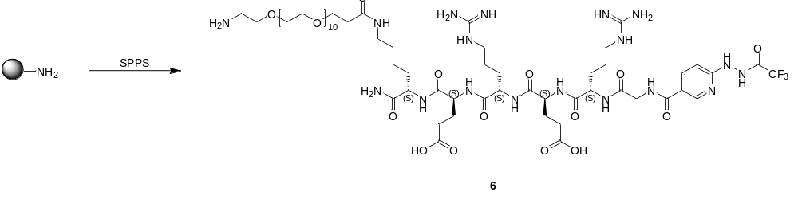Standard Fmoc chemistry was used throughout synthesis with Rink Amide MBHA resin (574 mg, 0.80 mmol). All amino acids FMOC-LYS(DDE)-OH, FMOC-GLU(OTBU)-OH, FMOC-ARG(PBF)-OH, FMOC-GLU-(OTBU)-OH, FMOC-ARG-(PBF)-OH, FMOC-GLY-OH and compound 5) were coupled using activator reagents (HBTU (2.85 eq) and DIEA (6.00 eq) in DMF) bubbling by N₂ for 30 min. And then, the resin was washed with DMF (20.0 ml) for 3 times. The resin was treated with 20% piperidine in DMF (20.0 ml) for 30 min for Fmoc deprotection. And then, the resin was washed with DMF (20.0 ml) for 5 times. Repeated the above step for next amino acid coupling at 20 °C. Dde was treated with hydrazine hydrate/DMF (3/97) 20 ml for 0.5 h twice. Amine-PEG₁₁-COOH were coupled using activator reagents (HBTU (2.85 eq) and DIEA (6.00 eq) in DMF) bubbling by N₂ for 30 mins. Then the resin was washed with DMF (20.0 ml) for 3 times. The coupling reaction was monitored by ninhydrin color reaction. The conversion was monitored by LCMS. LCMS indicated desired compound. After washing with MeOH (10.0 ml) and drying under vacuum. The peptide crude weight is 1.00 g. Added 5.00 ml of cleavage buffer (95.0% TFA/2.50% H₂O/2.50% TIS) to the flask containing the side chain protected peptide at room temperature (20 °C) and stirred for 2.5 hours. The peptide was precipitated with cold isopropyl ether (25.0 ml) and centrifuged (3 min at 3000 rpm). Isopropyl ether washed two additional times (25.0 ml). Dried the crude peptide under vacuum 2 hours. The residue was purified by prep-HPLC (NH₄HCO₃, basic condition) to give compound 6 (200 mg, 14.3% yield) as a white solid.
LCMS: ES11814-5-P1A
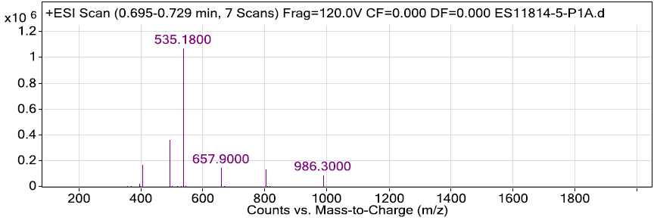
HPLC: ES11814-5-P1C
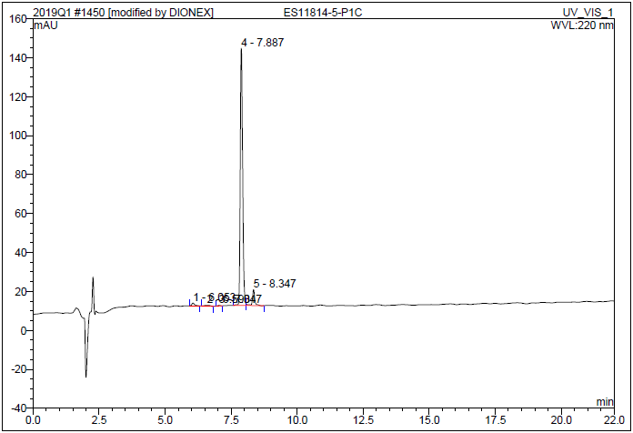
General procedure for preparation of C19012278:
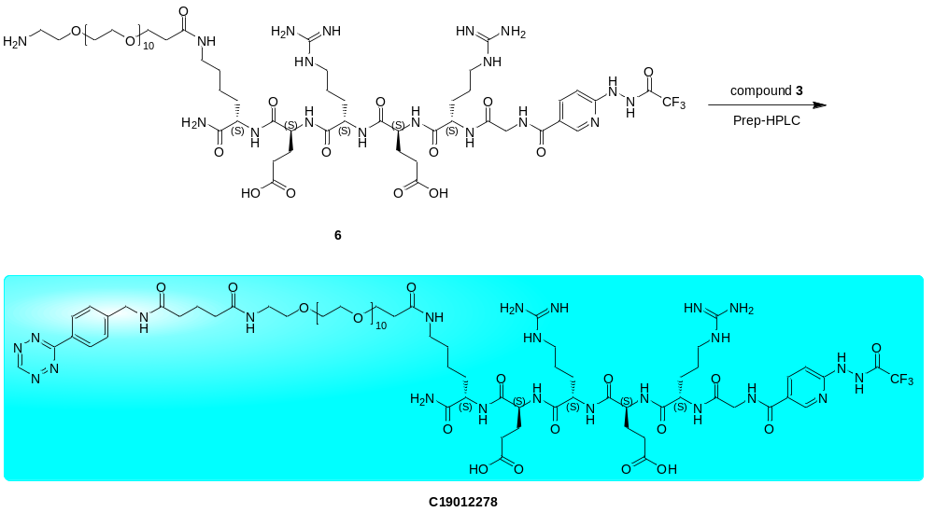
To a solution of compound 3 (36.6 mg, 121 μmol) in DMF (0.50 ml) was added HATU (30.8 mg, 81.0 μmol) and DIEA (20.9 mg, 162 μmol), stirred at 20 °C for 15 min, then compound 6 (65.0 mg, 40.5 μmol) was added to the mixture, stirred at 20 °C for another 1 h. The reaction was monitored by LCMS, LCMS showed the desired mass. The residue was purified by prep-HPLC (basic condition) to give C19012278 (80.6 mg, 33.2% yield) as a red solid.
LCMS:ES11814-6-P1A and ES11814-6-P1B
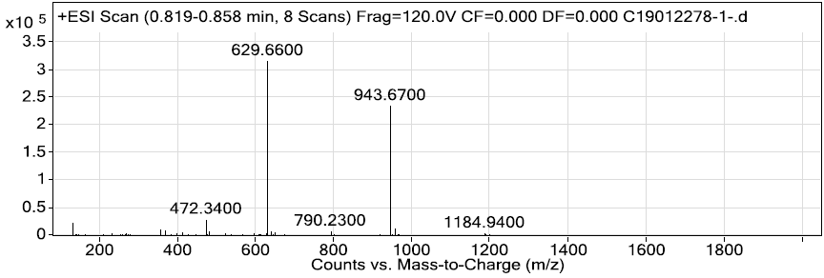
HPLC: ES11814-6-P1A
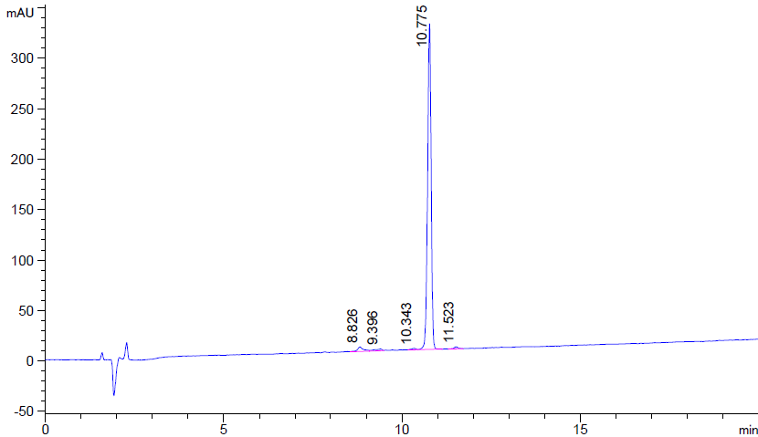
Xenograft Models
Six-eight week-old athymic BALB/c nude male mice were obtained from Nanjing Biomedical Research Institute of Nanjing University. Animals were housed in a pathogen-free environment under a 12-hour light/dark cycle with free access to food and water. HCT116 tumors were induced on the right shoulder by a subcutaneous injection of 1×10⁷ cells in a 100 μl cell suspension of a 1:1 mixture of PBS: Matrigel. The xenografts reached ideal size for imaging and biodistribution. Animal care and experimental procedures were approved by the Animals Ethics Committee of Zhongshan Hospital, Fudan University.

Supplementary Results
Supplementary Table 1: Biodistribution of ^{99m}Tc-HYNIC-Polypeptide-PEG₁₁-Tz. Mice bearing subcutaneous HCT116 xenografts were administered ^{99m}Tc-HYNIC-Polypeptide-PEG₁₁-Tz alone via tail vein injection. The mice were euthanized, and tissues of interest were harvested at 30 min, 2 h, and 6 h after the Tz-radioligand injection.
Tissue/Organ  (%ID/g) | Time
Tissue/Organ  (%ID/g) | 30 min | 2 h | 6 h
Blood | 0.24±0.03 | 0.02±0.01 | 0.02±0.01
Tumor | 0.12±0.08 | 0.04±0.03 | 0.02±0.00
Heart | 0.05±0.01 | 0.01±0.00 | 0.01±0.00
Lung | 0.24±0.04 | 0.06±0.04 | 0.03±0.00
Liver | 0.27±0.07 | 0.05±0.01 | 0.02±0.01
Spleen | 0.03±0.00 | 0.01±0.01 | 0.02±0.00
Stomach | 0.08±0.01 | 0.04±0.03 | 0.02±0.01
Small intestine | 0.07±0.02 | 0.02±0.01 | 0.02±0.00
Large intestine | 0.07±0.01 | 0.01±0.00 | 0.01±0.01
Muscle | 0.07±0.01 | 0.01±0.00 | 0.01±0.00
Bone | 0.05±0.01 | 0.02±0.00 | 0.05±0.02
Skin | 0.14±0.13 | 0.04±0.03 | 0.04±0.01
Brain | 0.01±0.01 | 0.00±0.00 | 0.01±0.00
Thyroid | 0.16±0.16 | 0.02±0.01 | 0.02±0.00
Faces | 0.01±0.00 | 0.03±0.00 | 0.05±0.00
Kidney | 4.84±1.89 | 4.59±0.82 | 2.98±1.12
Urine | 59.01±36.71 | 21.11±23.80 | 4.21±3.16

Supplementary Table 2: Biodistribution comparision of live mice bearing subcutaneous HCT116 xenografts preinjected with Cetuximab-TCO followed 24 h, 48 h and 72 h later by ^{99m}Tc-HYNIC-Polypeptide-PEG₁₁-Tz. The animals were euthanized, and tissues of interest were harvested at 6 h after ^{99m}Tc-HYNIC-Polypeptide-PEG₁₁-Tz. injection.

Tissue/Organ  (%ID/g) | Pretargeted time
Tissue/Organ  (%ID/g) | Cetuximab-TCO 24 h | Cetuximab-TCO 48 h | Cetuximab-TCO 72 h
Blood | 1.60±0.48 | 1.21±0.20 | 1.02±0.41
Tumor | 1.32±0.14 | 1.69±0.54 | 1.17±0.04
Heart | 0.12±0.07 | 0.08±0.02 | 0.07±0.02
Lung | 0.30±0.16 | 0.16±0.06 | 0.17±0.13
Liver | 0.31±0.05 | 0.36±0.05 | 0.29±0.02
Spleen | 0.14±0.08 | 0.10±0.05 | 0.10±0.05
Stomach | 0.06±0.01 | 0.05±0.00 | 0.08±0.01
Small intestine | 0.06±0.00 | 0.04±0.02 | 0.05±0.01
Large intestine | 0.07±0.01 | 0.04±0.01 | 0.04±0.00
Muscle | 0.05±0.02 | 0.05±0.04 | 0.03±0.01
Bone | 0.07±0.01 | 0.07±0.01 | 0.11±0.15
Skin | 0.21±0.10 | 0.15±0.09 | 0.10±0.04
Brain | 0.01±0.00 | 0.01±0.00 | 0.01±0.00
Thyroid | 0.15±0.06 | 0.17±0.05 | 0.09±0.03
Faces | 0.18±0.11 | 0.17±0.16 | 0.12±0.05
Kidney | 5.41±0.91 | 3.42±0.61 | 3.16±0.63
Urine | 16.50±9.48 | 21.98±7.18 | 9.86±4.03
Supplementary Table 3: Biodistribution comparision of live mice bearing subcutaneous HCT116 xenografts preinjected with Cetuximab-TCO followed 48 h later by ^{99m}Tc-HYNIC-PEG₁₁-Tz or ^{99m}Tc-HYNIC-Polypeptide-PEG₁₁-Tz. The animals were euthanized, and tissues of interest were harvested at 6 h after ^{99m}Tc-HYNIC- PEG₁₁-Tz or ^{99m}Tc-HYNIC-Polypeptide-PEG₁₁-Tz injection.
Tissue/Organ  (%ID/g) | Cetuximab-TCO 48 h/^{99m}Tc- HYNIC-PEG₁₁-Tz 6 h | Cetuximab-TCO 48 h/^{99m}Tc- HYNIC-Polypeptide-PEG₁₁-Tz 6 h
Blood | 1.12±0.13 | 1.21±0.20
Tumor | 1.81±0.23 | 1.69±0.54
Heart | 0.06±0.05 | 0.08±0.02
Lung | 0.14±0.06 | 0.16±0.06
Liver | 0.19±0.11 | 0.36±0.05
Spleen | 0.09±0.01 | 0.10±0.05
Stomach | 0.06±0.07 | 0.05±0.00
Small intestine | 0.08±0.13 | 0.04±0.02
Large intestine | 0.08±0.16 | 0.04±0.01
Muscle | 0.04±0.07 | 0.05±0.04
Bone | 0.09±0.08 | 0.07±0.01
Skin | 0.09±0.07 | 0.15±0.09
Brain | 0.01±0.02 | 0.01±0.00
Thyroid | 0.06±0.10 | 0.17±0.05
Faces | 28.55±24.66 | 0.17±0.16
Kidney | 0.14±0.32 | 3.42±0.61
Urine | 1.19±1.98 | 21.98±7.18

